Review of 3-Phase AC Circuits






PREPARED BY

DEEPAK KUMAR SAHOO
ASST.PROF.
DEPARTMET OF EE
RITE BHBANESWR

1

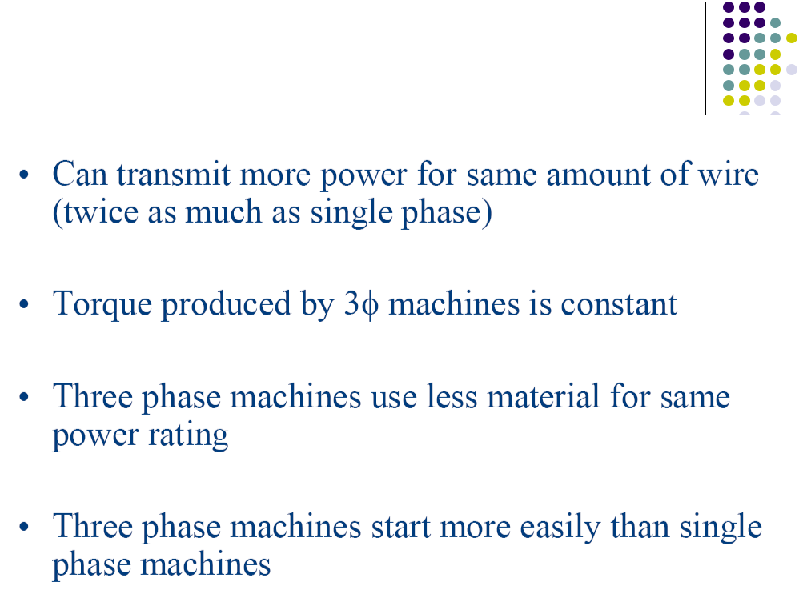
Advantages of 3-Phase Systems

2


Balanced 3-Phase Systems

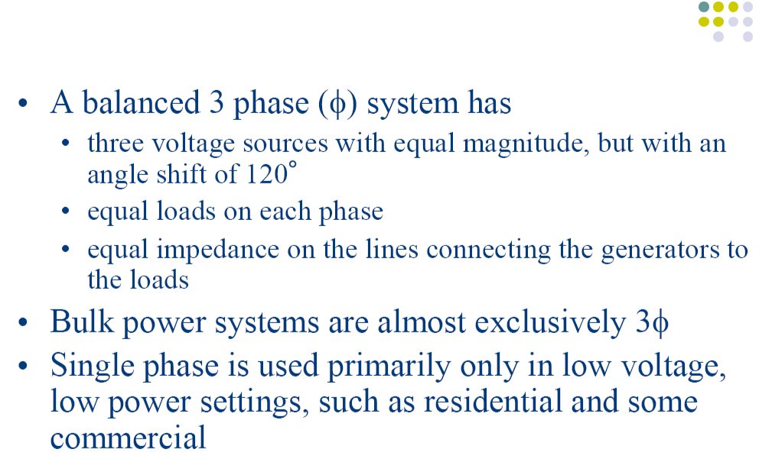

3

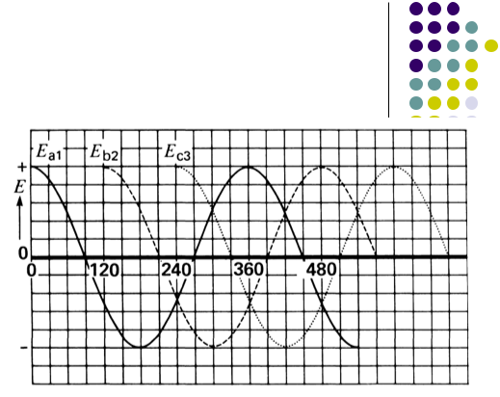
3-Phase Voltage Source


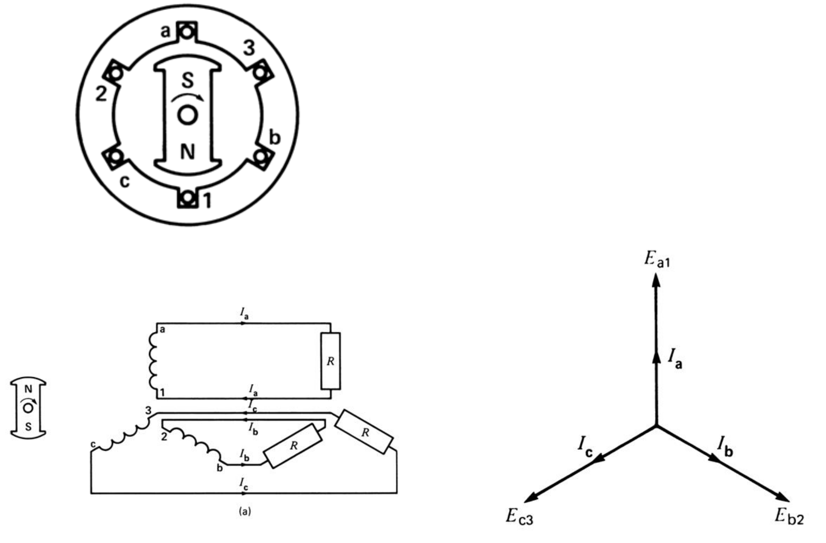

4

Neutral Wire Sharing

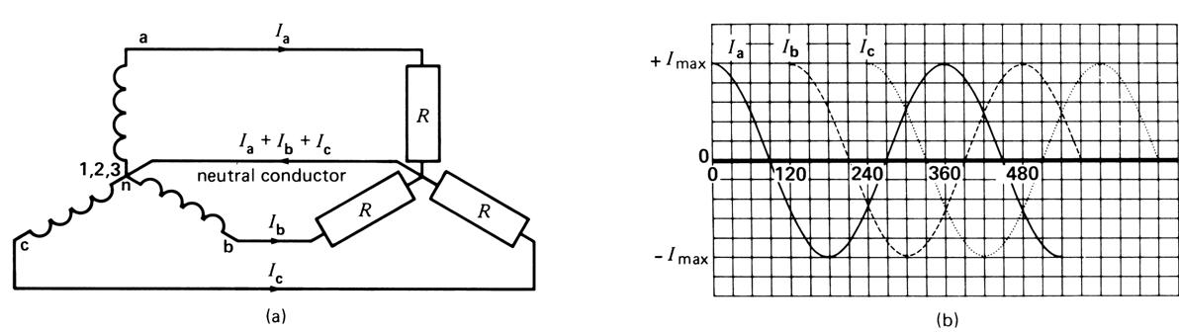

5


Neutral Current in Balanced Circuit = 0

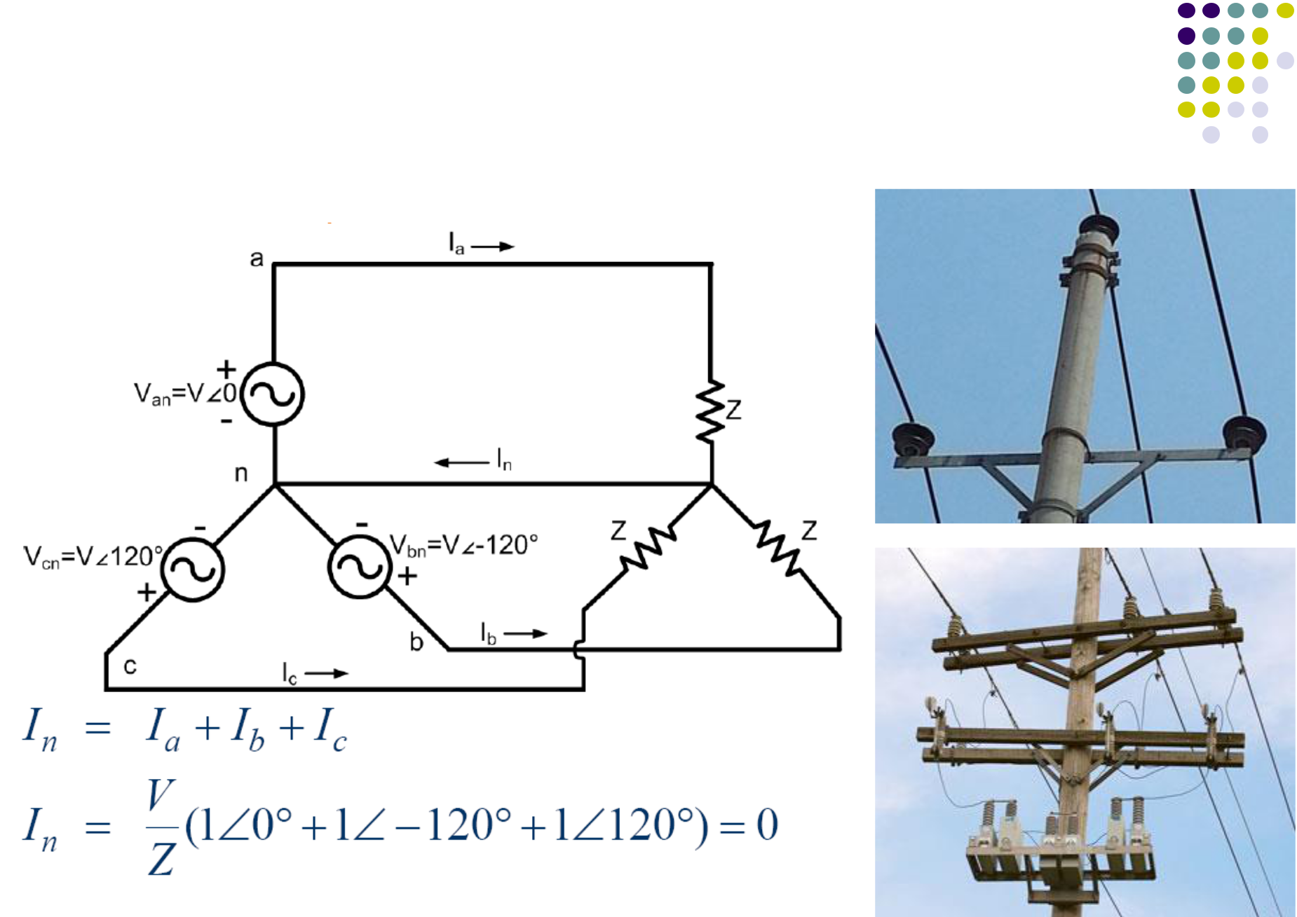

6

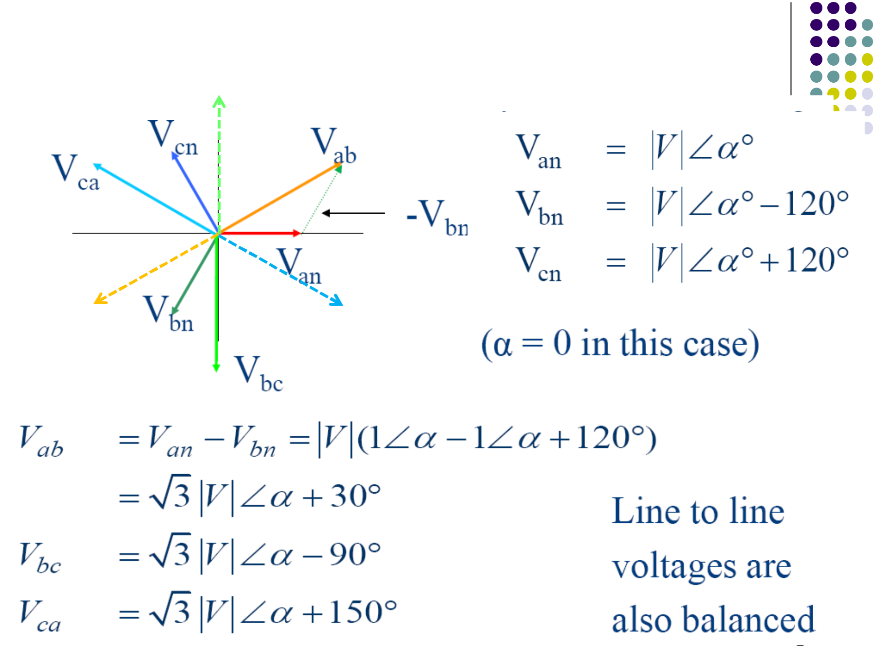
Phase Voltages and Line Voltages
^{V}ca

^{V}ba V_{ac}

7

Example of Phase and Line Voltages

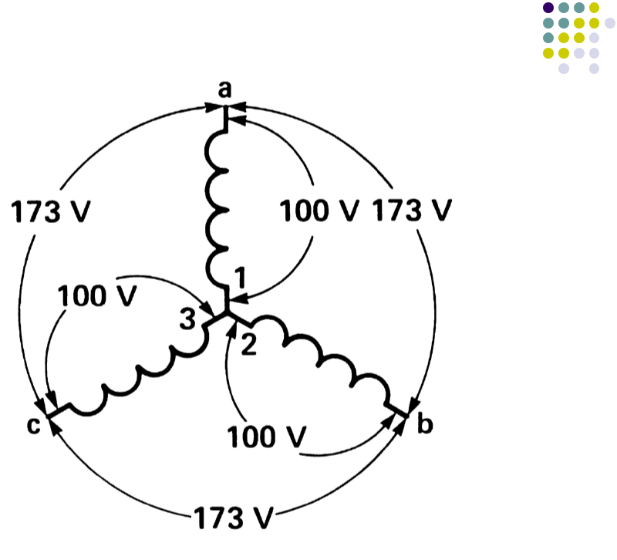

8

Y-Connected Load

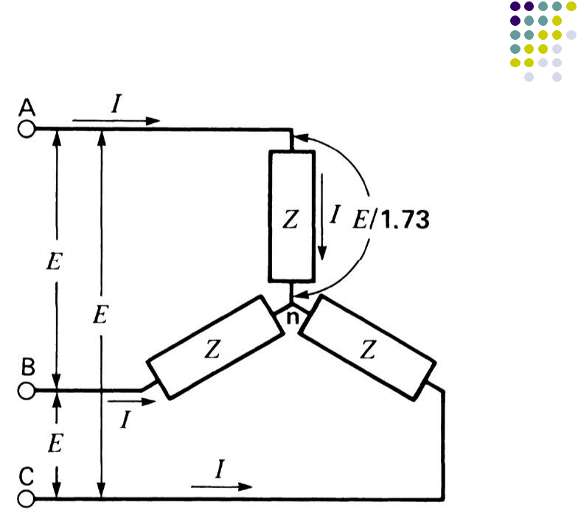

9

-Connected Load

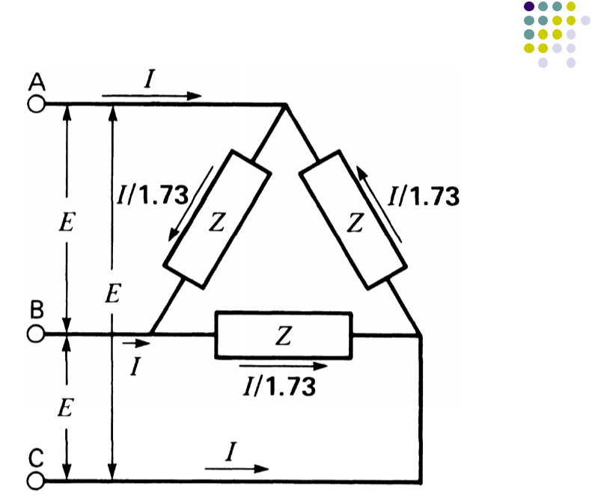

10

Power in Balanced 3-Phase Circuits

- The real power, reactive power, apparent power, complex power and power factor are the same in each phase.


- = 3Vp I cos(θ) = 3VL I cos(θ) Q = 3Vp I sin(θ) = 3VL I sin(θ)


11

Power measurement in 3-phase 4-wire circuit

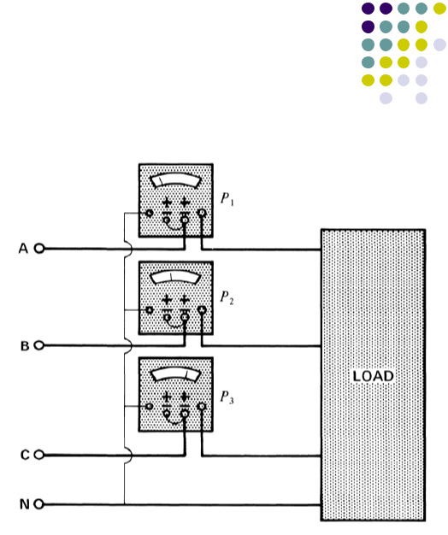

- If the load is balanced, then P₁ = P₂ = P₃. Hence, P_{T} = 3P₁

- If the load is unbalanced, P₁≠P₂≠P_{3,} Hence, P_{T} = P₁+P₂+P₃

12

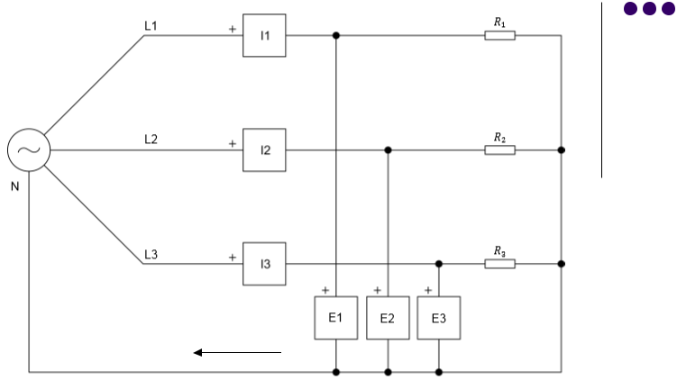
Example: 1


I_{N}

The phase voltage of the positive-sequence balanced source is 120 V. Let R1 = 100 Ω, R2 = 200 Ω, R3 = 300 Ω.

Compute the real power supplied by each phase, the neutral current, and the current imbalance which is defined as the maximum percentage deviation of any pair of phase currents relative to the average of the three phases.

Answer:

I1 = 1.2 A, I2 = 0.6 A, I3 = 0.4 A,

P1=144W,P2=72W,P3=48W,

I_{N} = 0.72 A, I_{im}= 63.7 % | 13


Power measurement in 3-phase 3-wire circuit: the 2-wattmeter method

- P_{T} = P₁+P₂

- The load can be Y-connected, -connected, balanced, or unbalanced.

- Any one of the 3 phases can be used as a reference.

- If the load is balanced, then P₁ = P₂ = P_{T}/2,
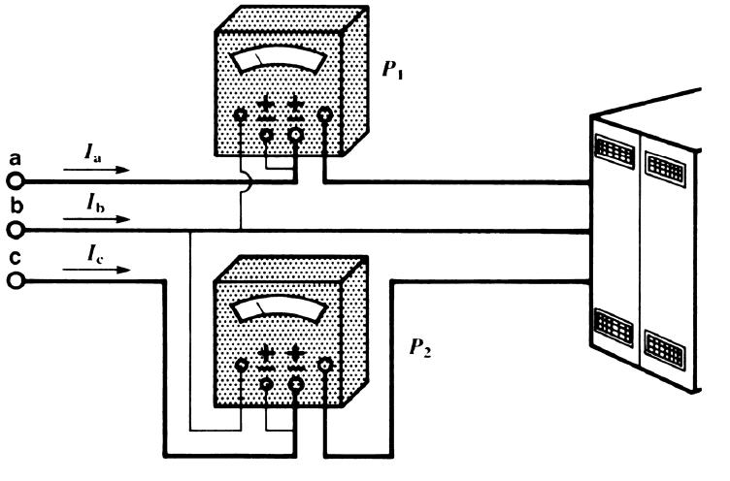

14

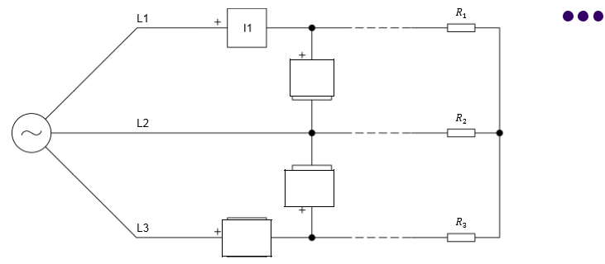
Example 2


^{E}12

N

^{E}32
I₃

The phase voltage of the positive-sequence balanced source is 120 V. Let R1 = 100 Ω, R2 = 200 Ω, R3 = 300 Ω.

Compute the real power supplied by each of the two wattmeters, the power supplied by each phase, and the current imbalance.

Answer:

E₁ = 120∟0º V, E₂ = 120∟-120º V, E₃ = 120∟+120º V, E12 = 208∟30º V,
E32 = 208∟90º V, E_{N} = 39.33∟-13.9º V
I1 = 0.823 ∟6.6º A, I2 = 0.68 ∟-135º A, I3 = 0.50 ∟130.9º A,
P12 = 157 W, P32 = 79 W, P_{tot} = 236 W.
P1 = 98 W, P2 = 79 W, P3 = 59 W, P_{tot} = 236 W ₁₅ I_{im} = 25%
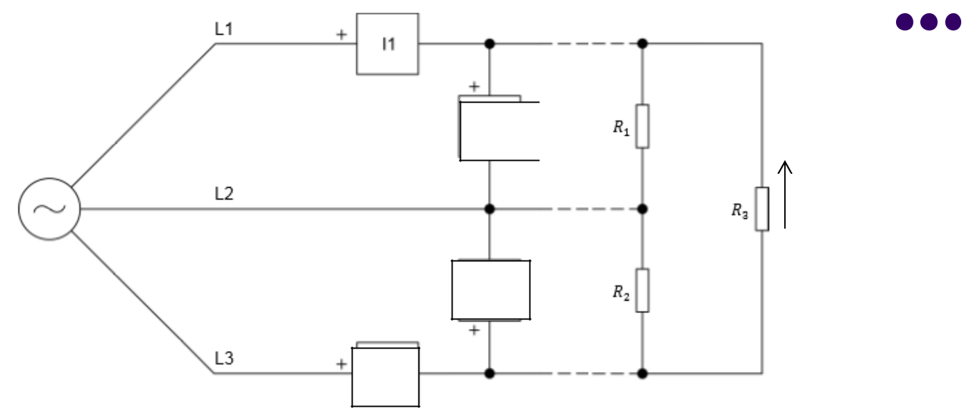
Example 3


E₁₂ ^{I12}

^{I}31

E₃₂ ^{I}23

I₃

The phase voltage of the positive-sequence balanced source is 120 V. Let R1 = 100 Ω, R2 = 200 Ω, R3 = 300 Ω.

Compute the real power measured by the 2 wattmeter method.

Answer:

I12 = 2.08 ∟30º A, I23 = 1.04 ∟-90º A, I31 = 0.69 ∟150º A,
I1 = 2.5 ∟16.2º A, I3 = 1.51 ∟113.3º A,
P12 = 505 W, P32 = 288 W, P_{tot} = 793 W,
Check: P_{tot} = 208^2/100 + 208^2/200+ 208^2/300 = 793 W,

16
Delta-Wye Transformation

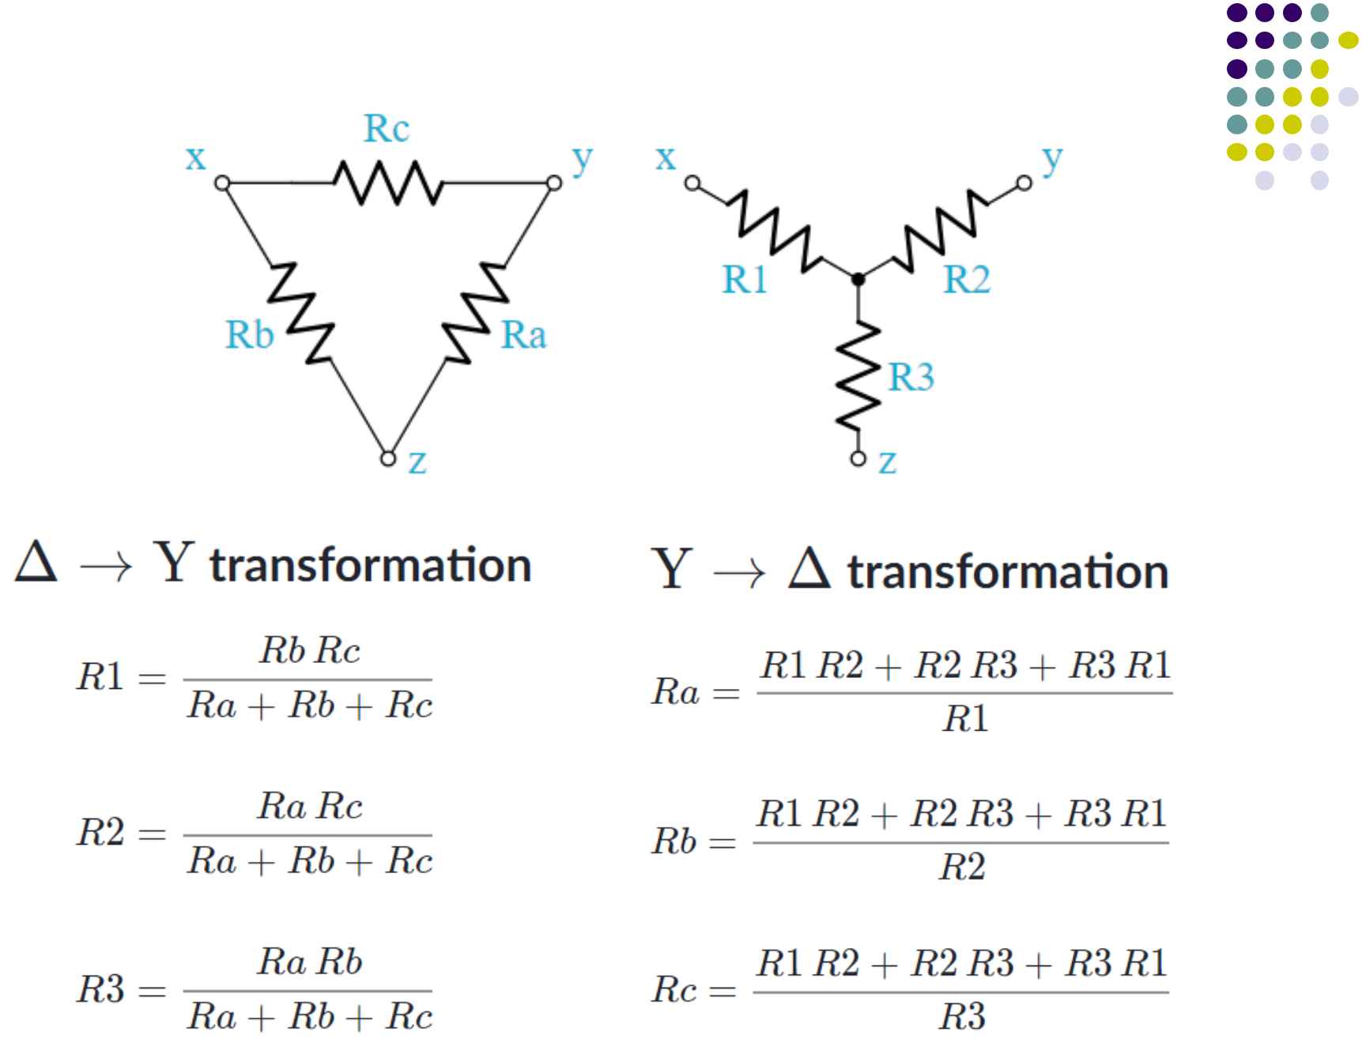

17

Measuring active power in a high power circuit

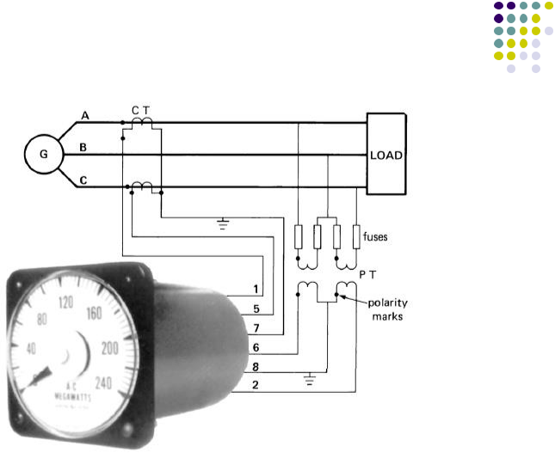

18

Per-Phase Analysis in Balanced 3-Phase Circuits

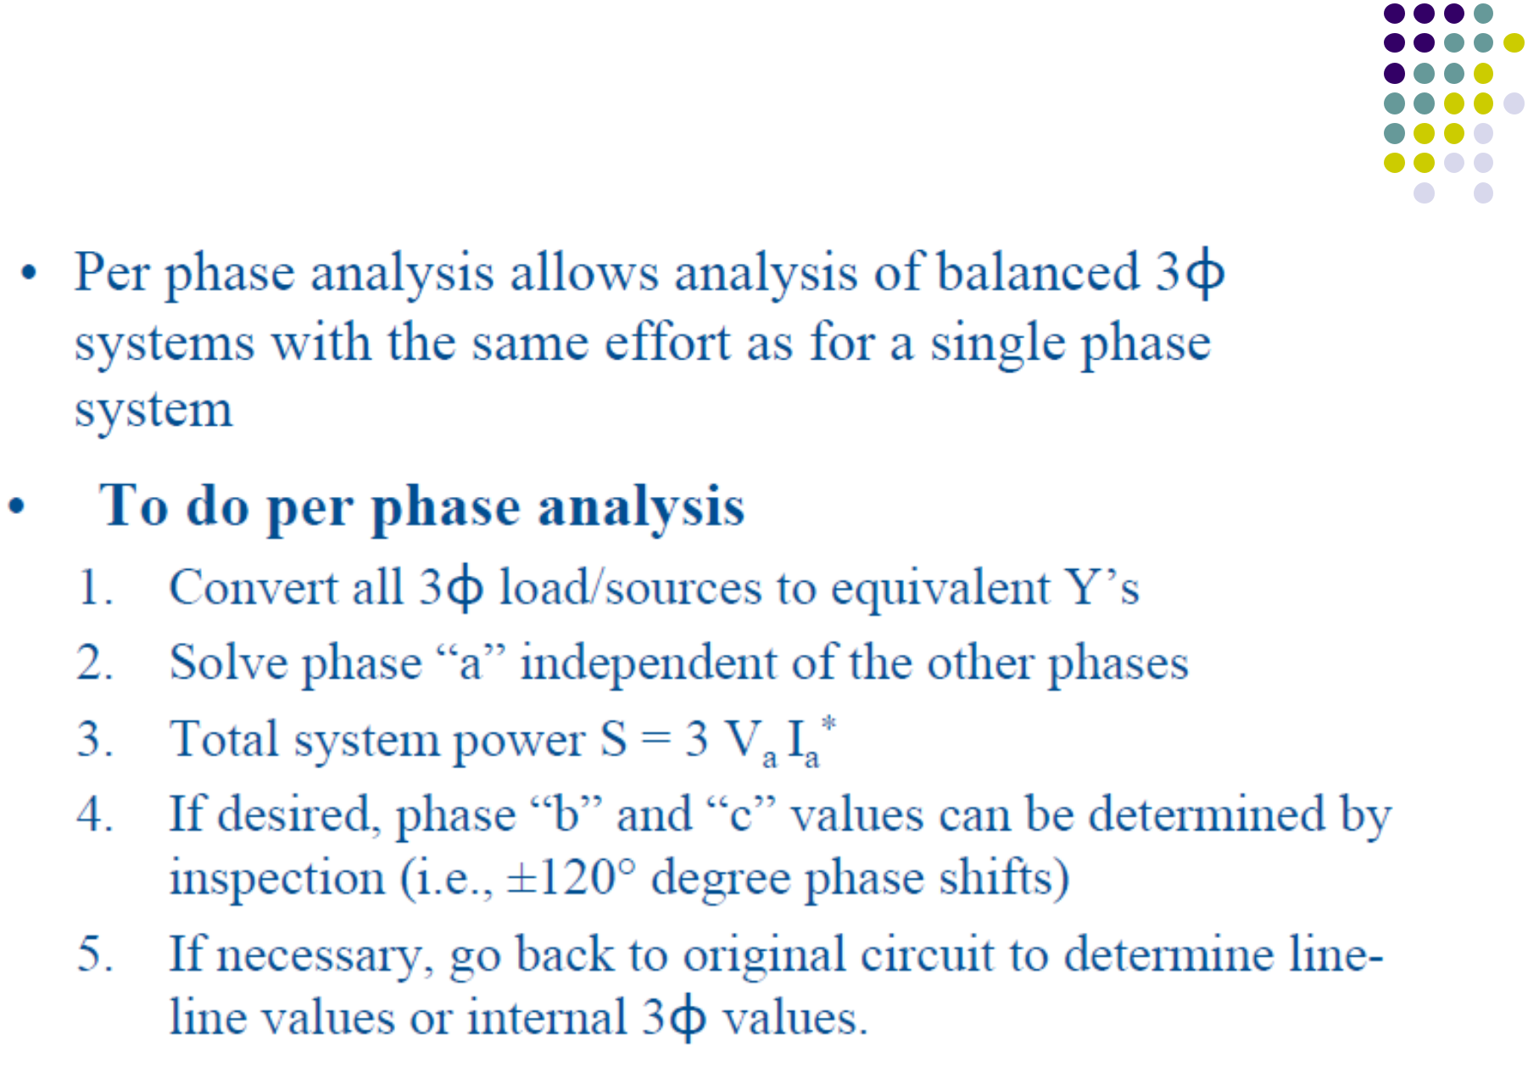

19

Example of per-phase analysis of balanced circuits


- Find the complex power supplied by each of the two sources.
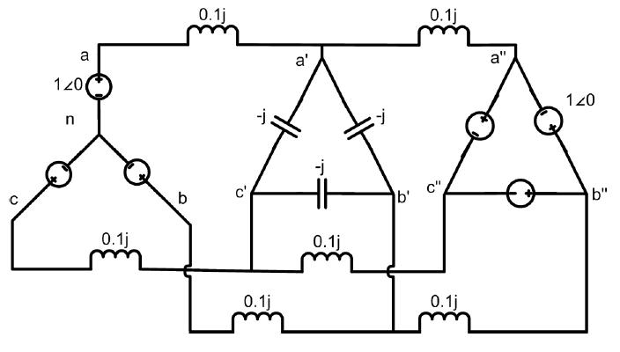

20
Solution
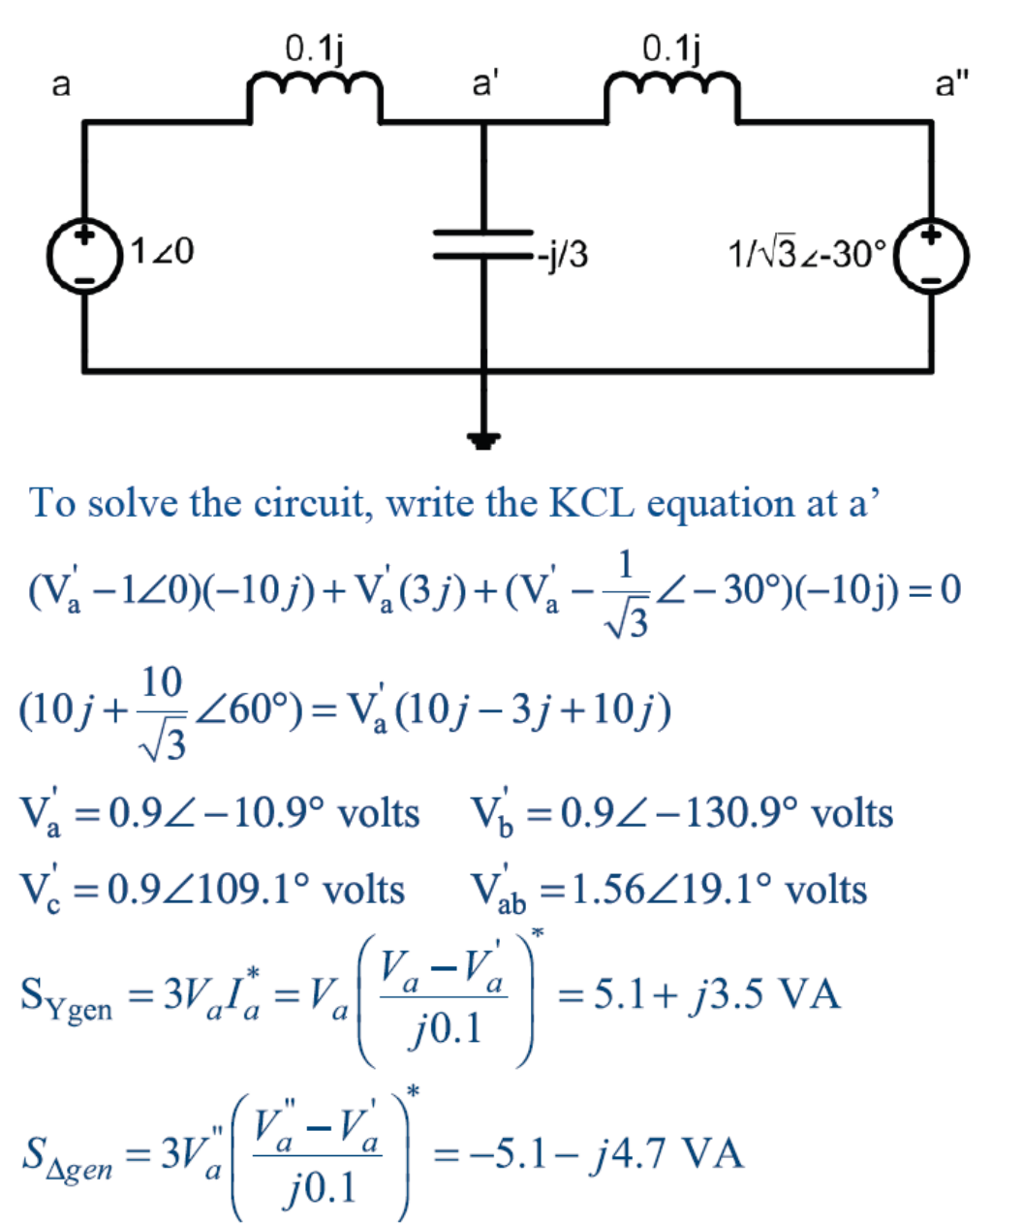

21

Example of 3-phase balanced circuit
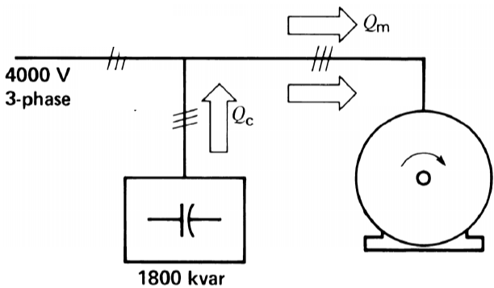

3-phase motor:

Pout = 3594x746 = 2,681 kW Pm= Pout/0.93 = 2,883 kW Sm = Pin/0.9 = 3,203 kVA Qm= 1,395 kVAR

Im = Sm/(1.73x4000) = 462 A

3-phase capacitor bank:
Qc = 1,800 kVAR

Ic = Qc/(1.73x4000) = 260 A Source Side:

Qs = Qm-Qc = -405 kVAR Ss = 2,911 kVA
PFs = 99% (lead)
Is = Ss/(1,73x4000) = 420 A

Pm
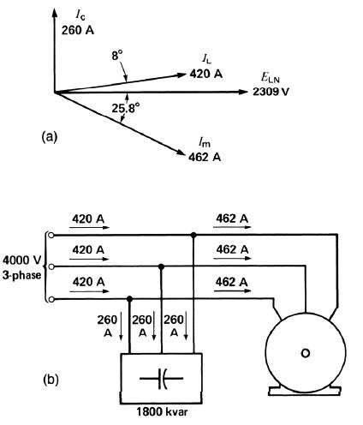

Pout = 3,594 hp

- = 93% PF=90%

22

Problems from Chap 2:

1, 2, 3, 4, 5, 6.

23
Practice problem

Consider the three-phase 3-wire load that is supplied by a balanced positive-sequence source where the rms values of phase voltages are equal to 120 V,

with phase “a” voltage is taken as a reference. The load impedances across phases a-b, b-c, and c-a are purely resistive as follows: Rab = 60Ω, Rbc = 90 Ω, Rca = ∞ (i.e, open circuit).

- Calculate the power measured by wattmeter P₁.

P1=……. W

- Calculate the power measured by wattmeter P₂.

P2 = …….. W

- Calculate the rms value of current I_{b}.
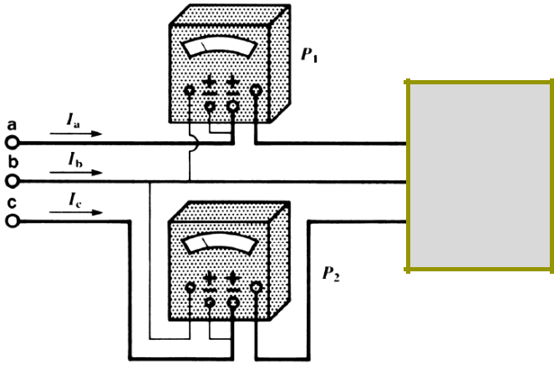

Ib = ….. A

- Repeat the above when Rca is replaced by 120 Ω.

P1 = ………. W

P2 = …….… W Ib = ………… A

Answer: (rounded to nearest integer)

- P1 = 721 W, 2) P2 = 481 W, 3) Ib = 5 A, 4) P1 = 901 W, P2 = 661 W, Ib = 5 A

3-phase

load

24
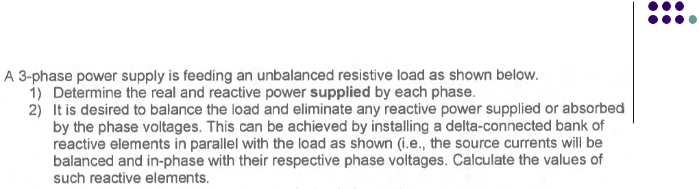
Homework Assignment # 2
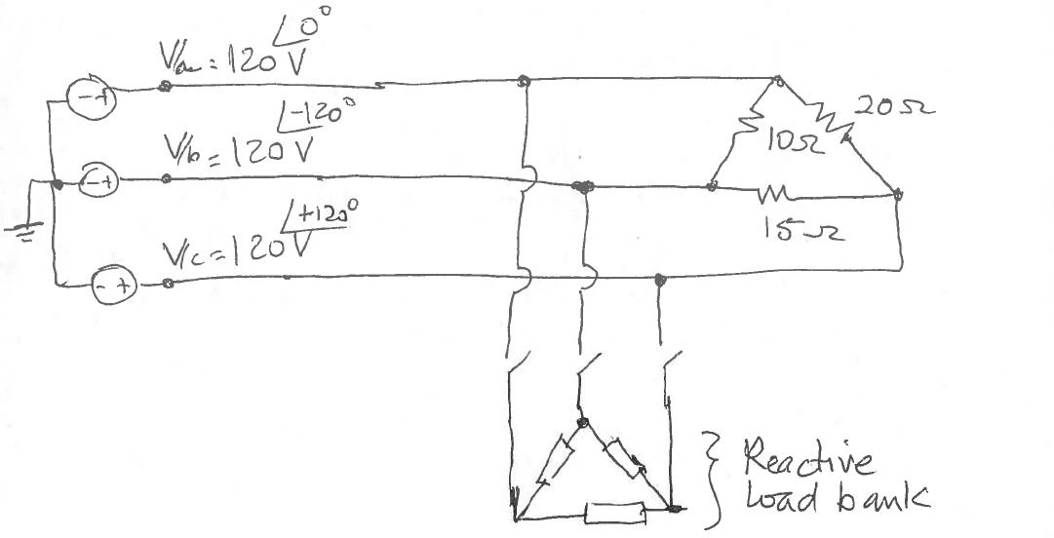

25

